EG Important Questions (CSE-A,B,C,D&E)
- Draw the Projections of a Cylinder of the Base 30mm diameter and axis 60mm long resting with its base on H.P such that the axis is making an angle of 30 degrees with H.P and Parallel to V.P. Draw its projections.
- A hexagonal pyramid side of base 30mm and axis 65mm long resting on V.P on one of its base edges. Draw the projection of solid when the axis make 45 degrees with V.P. Draw its projections.
- A Cone of base 30mm and axis 60mm long, laying one of its triangular face on the H.P and axis parallel to V.P, draw its projection.
- Draw the Projections of a pentagonal prism of the base of side 30mm and axis 60mm long Resting with its base on H.P such that the axis is making an angle of 30 degrees with H.P and Parallel to V.P. Draw its projection.
- A pentagonal prism, having a 30mm side and a 60mm long axis, is resting on its base on H.P. such that one of the rectangle faces is parallel to the V.P. it is cut by an auxiliary inclined plane whose V.T. is inclined 45degree with the reference line and passes through the mid-point of the axis. Draw the true shape of the truncated prism.
- A cone with a 40mm base diameter and a 60 mm long axis, rest on its base on the H.P. Draw the development of lateral surface when it is cut by an auxiliary inclined plane bisecting the axis and inclined at 45⁰ to the H.P.
- A hexagonal pyramid of height 80mm and base of sides 30mm is resting on its base in the H.P. with its two edges /sides to the V.P. it cut by an auxiliary inclined plane 60 degrees to H.P. and perpendicular to the V.P, and intersecting the axis at a point 40mm above the base. Draw Sectional plan, elevation and true shape of the section.
- A Pentagonal prism with a base of side 30mm and 60 mm long axis, rest on its base on the H.P. Draw the development of lateral surface when it is cut by an auxiliary inclined plane passing through its top right corner and inclined at 45 degrees to the H.P.

- Draw the conversion of the following Isometric view to Orthographic view.
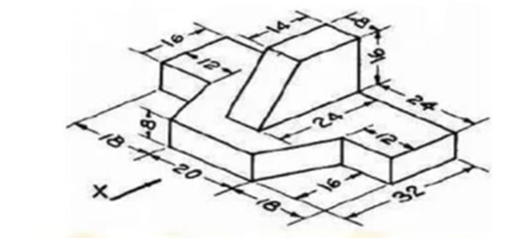

10 Draw the conversion of the following Isometric view to Orthogonal view.

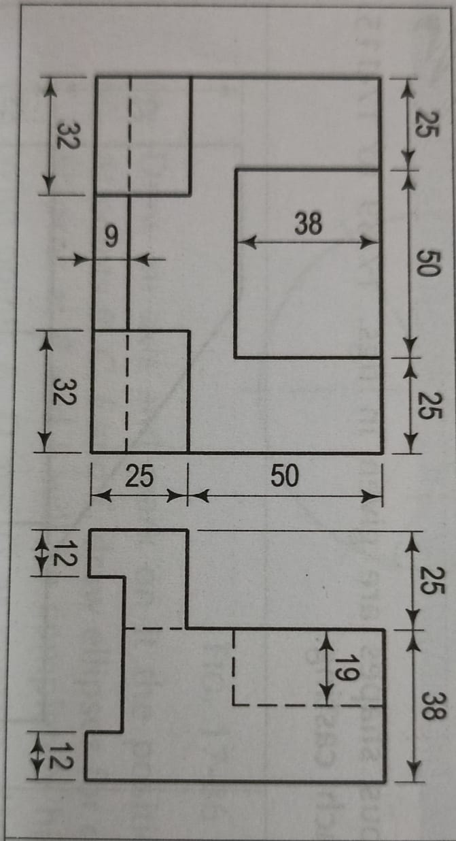
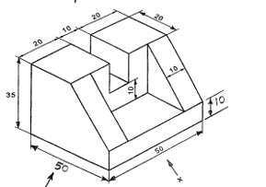
11.Draw the conversion of Ortho to Isometric views

12. Draw the conversion of the following Orthogonal view to Isometric view (first
angle projection)
